Job Title: | Hydrogeologist
Department: | Technical Services
Reports to: | Technical Lead - Water
Direct Reports: | None
Location: | Activity Based on Site
Contract Type: | Permanent
Grade: | CA5

Main purpose of the job

To provide analysis and conceptual understanding of hydrogeological data across the coalfields of Great Britain and to develop future strategies.

To collate, analyse, and manage the monitoring of underground mine water levels and associated datasets throughout the coalfields of Great Britain, in order to predict when and where new polluting discharges may occur due to rising mine water levels.

Responsibilities

Specific
- To analyse and appraise monitoring data, as collected by the Mining Remediation Authority’s contractors, and also supplied by third parties, to determine new trends or changes in trends.
- To support operational activities - monitor and assess the effectiveness of water level control by the completed preventive schemes and review their efficiency.
- To develop a detailed knowledge and awareness of the mine water recovery position in the coalfields and provide advice on risk areas where preventive schemes may be necessary. This advice may be strategic or detailed in nature.
- To input into programming future preventive schemes and future borehole and monitoring requirements.
- To provide hydrogeological input into the coal programme and the inland salinity programme.
- To respond, within agreed timescales, to requests for information from project managers, Licensing and Permissions, Public Safety, Planning, etc.
- To review data from contractors, and when appropriate work with them to achieve continual improvement of quality and timeliness of data entry.
- To contribute to maintenance of the IT systems related to Environmental Data Management, EDM, including Aquarius, and to maintain mine water team Geographical Information in Arc software and Inferis.
- To develop and maintain an expert knowledge of monitoring techniques and equipment, and assist the team in developing future strategies for monitoring.
- To contribute with others to maintain field technical store with an appropriate level of equipment and consumables, periodically reviewing the equipment available on the market.
- To occasionally conduct visits to field monitoring sites to install, maintain and check datalogging equipment and collect ad hoc additional data, as needed on a prioritised basis.
- To occasionally give presentations, with a suitable level of technical content to stakeholders, including environmental regulators.
- To produce factual reports and occasionally contribute to the production of complex technical reports by MRA or its advisors.
- To support with hydrogeological aspects of remediation schemes, public safety incidents, and occasionally tip work.
- To occasionally provide hydrogeological support and advice to metal mine projects, or programmes.
- To deputise for Senior Hydrogeologist or other colleagues in their absence.

General
- Act in line with the behaviours and values of the organisation.
- Manage your own performance to be accountable for meeting individual, team and corporate objectives.
- Act in accordance with the Scheme of Delegation and ensure propriety and regularity in the handling of public funds.
- Actively demonstrate the Mining Remediation Authority’s customer service standards expected of your role.
- Follow and contribute to the improvement of operational and team processes and procedures.
- Assist with the preparation and delivery of the team’s objectives, budgets and financial records.
- Identify opportunities and implement change leading to team development, system. improvement and ensuring good value for money.
- Maintain and develop positive stakeholder relationships in order to promote the Authority and assist it to meet its objectives.
- Support research and development projects.
- Ensure that the Authority’s statutory responsibilities are effectively discharged.
- Carry out any further reasonable requests from your line manager.

Values in Action
We expect all our colleagues to embody our core values and behaviours in their daily work.
Trusted
- We act with integrity
- We’re open and transparent
- We deliver on our commitments
Inclusive
- We promote a culture of mutual respect
- We recognise that our differences make us stronger
- We work with others to achieve our vision
Progressive
- We’re open minded and innovative
- We recognise that the past can help us shape the future
- We listen and learn
Our Values in Action framework outlines important behavioural indicators which help us demonstrate our values through our work together.
Hybrid Working Model
This role sits within our Hybrid Working Model. The designated hybrid arrangement for this post is outlined under “Location” on page 1 of this Job Description and reflects the requirements of the role and the organisation. Hybrid working arrangements may be reviewed and adjusted if business needs change.
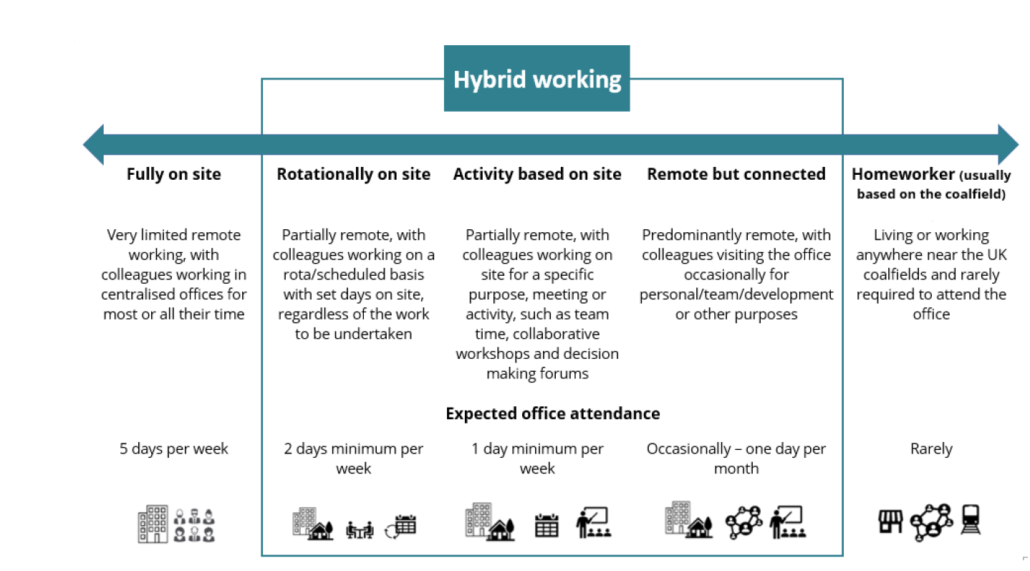

Person specification

Job Title: | Hydrogeologist |  | Department: |  | Technical Services
 | Essential |  | Desirable
Qualifications and Training | Bachelor's degree in an Earth Science-related subject.  Substantial experience in practical hydrogeology. |  | MSc in Hydrogeology, or related subject.  Demonstrable experience in practical hydrogeology.  Membership of an appropriate professional body, with Chartered status or progression towards this.
Experience and Knowledge | Supervision and management of contractors.  Experience of GIS systems.  Knowledge of drilling techniques and geophysical logging. |  | Experience of coal measures geology and/or UK coal mine workings and mine water.  Borehole siting and drilling supervision, and pumping test experience.
Skills and Abilities | Ability to interpret underground water monitoring data.  Ability to work under pressure.  Excellent communication and interpersonal skills  Excellent IT skills  Report writing skills |  | Use of hydrogeological software packages  Ability to specify and install data loggers in shafts and boreholes.
Other | - Full UK valid driving licence.  - Site visits across the UK  - Occasional nights away from home, up to two times per month.
 |  |  |  | 

