Job Title: | Customer Service Advisor
Department: | Customer Support and Services
Reports to: | Customer Service Manager
Direct Reports: | None
Location: | Rotationally On Site
Contract Type: | Permanent
Grade: | CA3

Main purpose of the job

As a customer service advisor, you will be responsible for providing a first class customer advice, information and transactional service to a variety of customers covering a wide range of services provided by the Mining Remediation Authority through digital, telephone and some face-to-face channels. You will form a vital role within the Customer Support and Services team and will be responsible for a variety of customer enquiries, including providing support for the communities we serve, interpretation of report information and advising customers on the right products for their needs as well as providing an immediate incident response service when required.

Responsibilities

Specific

- You will provide guidance, support and advice to customers on our products, service and any other queries that relate to the work we carry out as an organisation.

- You will have a full understanding of the reports order process and be able to support customer transactions through having the skills to analysis plans and plot a digitalised boundary to the customers’ requirements.

- You will respond to all types of enquiries and resolve where possible, taking ownership and only escalating more complex and specialist technical enquiries where needed.

General
- Act in line with the behaviours and values of the organisation.
- Manage your own performance to be accountable for meeting individual, team and corporate objectives.
- Act in accordance with the Scheme of Delegation and ensure propriety and regularity in the handling of public funds.
- Actively demonstrate the Mining Remediation Authority’s customer service standards expected of your role.
- Follow and contribute to the improvement of operational and team processes and procedures.
- Assist with the preparation and delivery of the team’s objectives, budgets and financial records.
- Identify opportunities and implement change leading to team development, system. improvement and ensuring good value for money.
- Maintain and develop positive stakeholder relationships in order to promote the Authority and assist it to meet its objectives.
- Support research and development projects.
- Ensure that the Authority’s statutory responsibilities are effectively discharged.
- Carry out any further reasonable requests from your line manager.

Values in Action
We expect all our colleagues to embody our core values and behaviours in their daily work.
Trusted
- We act with integrity
- We’re open and transparent
- We deliver on our commitments
Inclusive
- We promote a culture of mutual respect
- We recognise that our differences make us stronger
- We work with others to achieve our vision
Progressive
- We’re open minded and innovative
- We recognise that the past can help us shape the future
- We listen and learn
Our Values in Action framework outlines important behavioural indicators which help us demonstrate our values through our work together.
Hybrid Working Model
This role sits within our Hybrid Working Model. The designated hybrid arrangement for this post is outlined under “Location” on page 1 of this Job Description and reflects the requirements of the role and the organisation. Hybrid working arrangements may be reviewed and adjusted if business needs change.
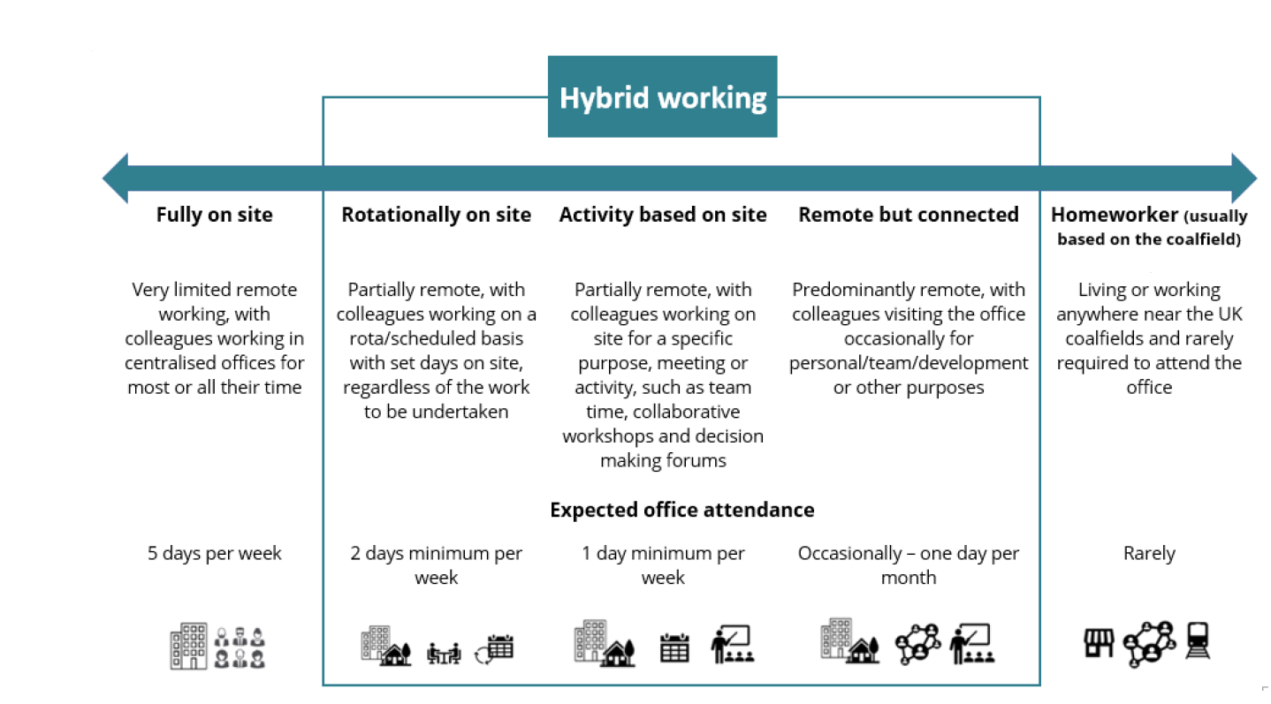

Person specification

Job Title: | Customer Service Advisor |  | Department: |  | Customer Service and Strategy
 | Essential |  | Desirable
Qualifications and Training | - (No minimum qualification set if candidate can demonstrate relevant experience required for the role) |  | - GCSEs at Grade C and above to include English and Maths  - NVQ diploma or equivalent in customer service  - Proficient in excel
Experience and Knowledge | - Previous experience in an customer service environment  - Previous experience in customer advisory role  - Experience of using Microsoft Office, including teams and excel  - Experience of front-line customer service provision through a variety of access channels  - Experience of managing challenging customers |  | - Experience of incident response situations  - Experience of using technical information systems
Skills and Abilities | - Excellent written and verbal communication skills  - Excellent time management skills and ability to multi-task and prioritise work  - Excellent listening skills  - Ability to use positive language  - Ability to demonstrate patience  - Ability to work under pressure
Other
 |  |  |  | 

